**Tool Condition Monitoring Method in Milling Process Using Wavelet Transform and Long Short-Term Memory**

Fatemeh Aghazadeh1, Antoine Tahan2 and Marc Thomas3

1 Departementde Génie mécanique, École de Technologie Supérieure, 1100, rue Notre-DameOuest, Montréal (Québec),Canada

[fatemeh.aghazadehkouzekonani.1@ens.etsmtl.ca](mailto:fatemeh.aghazadehkouzekonani.1@ens.etsmtl.ca)

2 Departementde Génie mécanique, École de Technologie Supérieure, 1100, rue Notre-DameOuest, Montréal (Québec),Canada

[antoine.tahan@etsmtl.ca](mailto:antoine.tahan@etsmtl.ca)

3 Departementde Génie mécanique, École de Technologie Supérieure, 1100, rue Notre-DameOuest, Montréal (Québec),Canada

[marc.thomas@etsmtl.ca](mailto:marc.thomas@etsmtl.ca)

# ***Abstract***

*Industrial automation is a promising move to fulfill today’s competitive manufacturing industry demands by lowering operation costs, increasing productivity and quality. Monitoring the production process is one of the important steps toward total autonomy of manufacturing plants, which reduces routine checks, enables proactive maintenance and reduces repair costs. This research investigates tool wear as one of the most common faults in milling process during cutting of the D2 high speed steel as a hard to cut material using Carbide Walter End Mill Protostar tool. Vibration signal is chosen to represent the system status due to its applicability in industry. Signals are transformed into time-frequency domain using Wavelet Transform method to reveal both time domain and frequency domain features of the signal simultaneously. In order to model the complex and non-linear relations between tool wear and vibration signals under varying cutting parameters, a deep learning based algorithm, Long Short-Term Memory (LSTM) Artificial neural networks (ANNs) is employed. Deep learning algorithms are getting lots of attention recently within the diagnosis and prognosis community because of their exceptional performance in exploiting information in big data to solve complex problems. LSTM network is a type of recurrent ANNs that have some internal cells that act as long-term or short-term memory units, which is most suitable for sequential data and time series like vibration signals in our analysis. After designing the system, performance of the monitoring method is validated using experimentally acquired data with K2X10 Huron high speed CNC machine in LIPPS and Dynamo labs of ETS.*

# ***Keywords***

## Deep Learning, Tool Wear, Wavelet Transform, Condition Monitoring, Time-Frequency Transformation, Machining Process

**1. Extended summary**

Machining processes are key components of industrial manufacturing, which requires higher productivity, parts quality, workers safety and lower operational costs. Therefore, there is growing demand to make the machining operation autonomous. Along with other initiatives in automation, online monitoring of machining process is beneficial to assure the production safety and quality. Tool wear is one of the most common and costly defects of the machining process, which is caused by excessive, contact forces and friction between cutting tool and workpiece material, high temperatures in the cutting surfaces and pressure of the chips on the tool. It may deteriorate the surface finish or cause damage or breakage to the tool, workpiece or machining center if is not detected and fixed on time ‎[1]. Therefore, designing a reliable and robust online automatic tool condition monitoring (TCM) system is in high demand to actively monitor the cutting process and provides actionable reports of tool condition status.

Tool condition monitoring (TCM) systems can be divided into two main sub-categories: direct and indirect methods. Direct methods involve a procedure to directly measure actual value of faults with a laser, optical or ultra-sonic sensor. This could be costly and causes interruption in the manufacturing process for the measurements. Indirect methods in contrast employs physical parameters of the system such as force, vibration, etc. to indirectly reflect the status of the system ‎[2]. Indirect methods can be used to fulfil TCM requirements as an alternative to indirect methods with accurate results and acceptable cost‎ [3]. Another advantage of this approach is that the same sensor can be used for multiple monitoring purposes.

Recently, deep learning algorithms draw attention of researchers in different fields due to their promising capabilities to solve complex challenges ‎[16]. Deep learning refers to machine learning algorithms with deep multiple layers which enable them to learn highly complex patterns from even low-processed to raw signals ‎[17]. In the era in which sensors are continuously producing enormous amounts of data, such techniques are in need to make the most information out of this data. These algorithms are less dependent on applications and frameworks and they are most efficient to outperform other methods when the relationship between the input data and desired outputs are complex ‎[18].

In this study, a TCM system is proposed using LSTM ANNs as a powerful and state of the art deep learning algorithm. Vibration signals from ETS experimental dataset are used to develop the monitoring system. Signals are processed using Wavelet method to transform them to time-frequency domain. Afterwards, the frequency bands energies calculated in the previous step is fed to the LSTM network as the features to construct the monitoring system. The algorithm accuracy is compared with a baseline Multi-Layer Perceptron (MLP) ANNs.

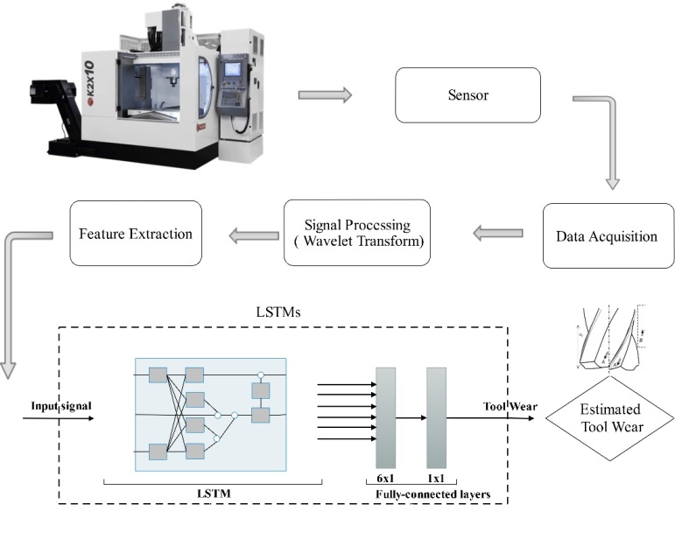

Figure 1.The monitoring system framework

In the signal acquisition step, an accelerometer is used to capture vibration data of the machine spindle for further processing. The framework of the monitoring system of this research is presented in Figure1. Signals are processed after the acquisition step to extract informative fault indicators and remove noise. Time-frequency analysis is used for this step because of its superior potential in revealing the time variant characteristics of the signals in frequency domain using Morlet wavelet transform method.

In the next step, a set of features are extracted from the wavelet transform to describe the fault properly. The signal energy in different frequency bands are used as the monitoring features. Therefore, minimum pre-processing is implemented to explore the capability of LSTMs in eliminating unnecessary information and magnifying relevant features. In contrast to other hand-crafted feature learning models, deep learning methods are capable to provide an effective prediction tool for fault detections by learning robust feature representations directly from input signals.

A deep LSTMs model is proposed in this paper to accurately predict the faults in machining process. The keras deep learning library is employed ‎[22] with tensorflow as the back-end ‎[23] to implement the proposed model. The proposed architecture of the paper involves an LSTM with four neurons in the first hidden layer. Then the output is fed into two fully-connected layers. The fully-connected layers are responsible to compute the softmax activation with a matrix multiplication followed by a bias in order to produce the prediction value. Mean Absolute Error (MAE) is chosen as the loss function. The model is fit during 2000 training epochs.

A set of experiments are performed to measure tool flank wear during machining of hard to cut materials. K2X10 Huron high speed CNC machine of the LIPPS laboratory at ETS is used to perform the experimental tests. A tri-axial accelerometer was mounted on the spindle of the machine with a sensitivity of 100mV/g for measuring acceleration.

A robust tool condition monitoring method is proposed and validated with ability to tolerate changing cutting parameters. Spindle vibration signals from the ETS dataset are used as the fault indicator. Wavelet transform time-frequency transformation method is employed for the signal processing step due to its great applicability to process signals and reveal rich information in both time and frequency domain simultaneously and its proven performance in this application. A deep LSTM based ANNs method is also implemented as the last step to model the complex relationships between extracted features and tool wear.

Time frequency step of the research revealed information on both time domain and frequency domain characteristics of the signals and the study confirms its performance and effectiveness in tool wear monitoring. Table 1 report the comparative results of the LSTM ANNS based proposed methodology of the paper versus MLP ANNs which is one of the most common and widely used ANNs in the Literature. Based on the results, LSTM outperforms MLP with above 10% in accuracy and it has a significantly lower RMSE for both training and test results. So it proves the applicability of LSTM for tool wear estimation.

As the next steps of this study, the results will be validated with other common sensors in this application, especially more economic and applicable sensors such as power and current sensors. In addition, sensor fusion techniques will be investigated at different levels of analysis to increase accuracy and robustness of the system.

**References**

1. Kunpeng Zhu and Birgit Vogel-Heuser. Sparse representation and its applications in micro-milling condition monitoring: noise separation and tool condition monitoring. The International Journal of Advanced Manufacturing Technology, 70 (1-4):185–199, 2014.
2. A Siddhpura and R Paurobally. A review of flank wear prediction methods for tool condition monitoring in a turning process. The International Journal of Advanced Manufacturing Technology, 65(1-4):371–393, 2013.
3. Jose Vicente Abellan-Nebot and Fernando Romero Subiron.´ A review of machining monitoring systems based on artificial intelligence process models. The International Journal of Advanced Manufacturing Technology, 47(1-4): 237–257, 2010.
4. Ning Li, Yongjie Chen, Dongdong Kong, and Shenglin Tan. Force-based tool condition monitoring for turning process using v-support vector regression. The International Journal of Advanced Manufacturing Technology, 91(1-4): 351–361, 2017.
5. MHS Harun, MF Ghazali, and AR Yusoff. Analysis of tri-axial force and vibration sensors for detection of failure criterion in deep twist drilling process. The International Journal of Advanced Manufacturing Technology, 89(9-12): 3535–3545, 2017.
6. Javad Soltani Rad, Youmin Zhang, and Chevy Chen. A novel local time-frequency domain feature extraction method for tool condition monitoring using s-transform and genetic algorithm. IFAC Proceedings Volumes, 47(3):3516–3521, 2014a.
7. Javad Soltani Rad, Ensieh Hosseini, Youmin Zhang, and Chevy Chen. Online tool wear monitoring and estimation using power signals and stransform. In Control and Fault-Tolerant Systems (SysTol), 2013 Conference on, pages 234– 238. IEEE, 2013.
8. T Segreto, A Simeone, and R Teti. Multiple sensor monitoring in nickel alloy turning for tool wear assessment via sensor fusion. Procedia CIRP, 12:85–90, 2013.
9. Adam G Rehorn, Jin Jiang, and Peter E Orban. Stateof-the-art methods and results in tool condition monitoring: a review. The International Journal of Advanced Manufacturing Technology, 26(7): 693–710, 2005.
10. Zhipeng Feng, Ming Liang, and Fulei Chu. Recent advances in time–frequency analysis methods for machinery fault diagnosis: A review with application examples. Mechanical Systems and Signal Processing, 38(1):165–205, 2013.
11. Adam G Rehorn, Ervin Sejdic, and Jin Jiang. Fault di-´ agnosis in machine tools using selective regional correlation. Mechanical Systems and Signal Processing, 20(5):1221–1238, 2006.
12. Javad Soltani Rad, Youmin Zhang, Fatemeh Aghazadeh, and Zezhong Chevy Chen. A study on tool wear monitoring using time-frequency transformation techniques. In Innovative Design and Manufacturing (ICIDM), Proceedings of the 2014 International Conference on, pages 342– 347. IEEE, 2014b.
13. K Patra, AK Jha, Tibor Szalay, J Ranjan, and Laszl´ o´ Monostori. Artificial neural network based tool condition monitoring in micro mechanical peck drilling using thrust force signals. Precision Engineering, 48:279–291, 2017.
14. CK Madhusudana, Hemantha Kumar, and S Narendranath. Face milling tool condition monitoring using sound signal. International Journal of System Assurance Engineering and Management, 8 (2):1643–1653, 2017.
15. DA Tobon-Mejia, Kamal Medjaher, and Noureddine Zerhouni. Cnc machine tool’s wear diagnostic and prognostic by using dynamic bayesian networks. Mechanical Systems and Signal Processing, 28:167–182, 2012.
16. Jurgen Schmidhuber.¨ Deep learning in neural networks: An overview. Neural networks, 61:85– 117, 2015.
17. Li Deng. A tutorial survey of architectures, algorithms, and applications for deep learning. APSIPA Transactions on Signal and Information Processing, 3, 2014.
18. Feng Jia, Yaguo Lei, Jing Lin, Xin Zhou, and Na Lu. Deep neural networks: A promising tool for fault characteristic mining and intelligent diagnosis of rotating machinery with massive data. Mechanical Systems and Signal Processing, 72:303–315, 2016.
19. Luyang Jing, Ming Zhao, Pin Li, and Xiaoqiang Xu. A convolutional neural network based feature learning and fault diagnosis method for the condition monitoring of gearbox. Measurement, 111:1–10, 2017.
20. Rui Zhao, Ruqiang Yan, Zhenghua Chen, Kezhi Mao, Peng Wang, and Robert X Gao. Deep learning and its applications to machine health monitoring: A survey. arXiv preprint arXiv:1612.07640, 2016.
21. Zachary C Lipton, David C Kale, Charles Elkan, and Randall Wetzel. Learning to diagnose with lstm recurrent neural networks. arXiv preprint arXiv:1511.03677, 2015.
22. Franc¸ois Chollet et al. Keras, 2015.
23. Mart´ın Abadi, Ashish Agarwal, Paul Barham, Eugene Brevdo, Zhifeng Chen, Craig Citro, Greg S Corrado, Andy Davis, Jeffrey Dean, Matthieu Devin, et al. Tensorflow: Large-scale machine learning on heterogeneous distributed systems. arXiv preprint arXiv:1603.04467, 2016.