NAFID - A Grid Tool for output only modal analysis
Thanh-Trung Do, Viet-Hung Vu¹ and Zhaoheng Liu
Department of mechanical engineering, École de technologie supérieure, Montreal (QC), H3C 1K3, Canada
¹ Corresponding: viet-hung.vu@etsmtl.ca

Abstract:

In this paper, we propose a technique to enhance and facilitate the output only modal analysis of systems and structures by using the vector autoregressive (VAR) model. As we have witnessed, the VAR model with its robustness, accuracy and noise - excitation resistance is beneficial for output only modal analysis. However, the VAR model and others parameters models have to deal with the variation of the model orders such as the frequency stabilization diagram. A grid technique is introduced to classify the natural frequencies and damping ratios in order to automatically evaluate its stabilization. The combination of the grid technique and the stabilization diagram will allow to users to have a better perspective of the modal parameters and a more accurate modes. The method is implemented and built in Matlab as the NAFID-tool which is users friendly and interactive. Examples on simulations of a MDOF system and on a real structure the applicability of the technique.
Keywords: Output-only modal analysis, multidof system, vector autoregressive model, grids, stabilization diagram.
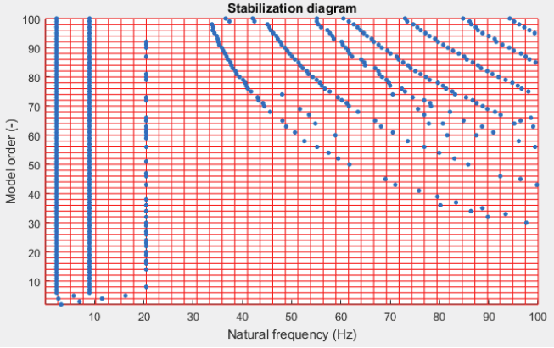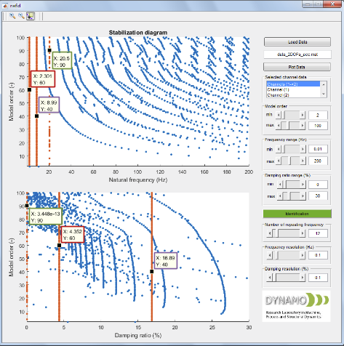
Fig. 5. Grids on the frequency stabilization diagram Fig. 7. NAFID interactive Tool
References:

- Pandit S. M., (1991), Modal and spectrum analysis: Data dependent systems in state space. J. Wiley and Sons, New-York, N. Y. 415p.
- Fassois S. D. (2001) Parametric identification of vibrating structures. In: S.G. Braun, D. J. Ewins and S. S. Rao (Ed.) Encyclopedia of Vibration. Acad. Press, N. York: 673-685.
- Vu,V.H., Z. Liu, M. Thomas and B. Hazel, (2016), Operational modal analysis of a light-weight robot with a rotating tool installed at the end-effector, Journal of Mechanical Engineering Science, Part C, 1:13.
- Vu V.H., M. Thomas, F. Lafleur and L. Marcouiller, (2013), Toward an automatic spectral and modal identification from operational modal analysis, Journal of Sound and Vibration, Elsevier, 332 (1): 213-227.
- Vu V.H., M. Thomas, A.A. Lakis and L. Marcouiller, (2011), Operational modal analysis by updating autoregressive model, Mechanical systems and signal processing (MSSP), Elsevier, 25(3): 1028-1044.

